**SP-PnP-JS**SP PnP JS are patterns and practices that the core JavaScript library offers. They are simplified common operations with SharePoint to help developers concentrate on business logic without worrying much about the underlying technical implementation. It contains fluent APIs to work with SharePoint REST APIs.  
  
**Create SPFx Solution**

Open the command prompt. Create a directory for SPFx solution.

1. md spfx-crud-sppnpjs

Navigate to the above-created directory.

1. cd spfx-crud-sppnpjs

Run Yeoman SharePoint Generator to create the solution.

1. yo @microsoft/sharepoint

Yeoman generator will present you with the wizard by asking questions about the solution to be created.

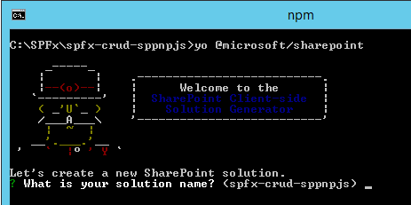

**Solution Name**Hit Enter to have a default name (spfx-crud-sppnpjs in this case) or type in any other name for your solution.  
  
Selected choice - Hit enter

**Target for component**Here, we can select the target environment where we are planning to deploy the client webpart; i.e., SharePoint Online or SharePoint OnPremise (SharePoint 2016 onwards).  
  
Selected choice - SharePoint Online only (latest)

**Place of files**We may choose to use the same folder or create a subfolder for our solution.  
  
Selected choice - Same folder.

**Deployment option**Selecting Y will allow the app to be deployed instantly to all sites and will be accessible everywhere.  
  
Selected choice - N (install on each site explicitly)

**Type of client-side component to create**We can choose to create client-side webpart or an extension. Choose the webpart option.  
  
Selected choice - WebPart.

**Web part name**Hit enter to select the default name or type in any other name.  
  
Selected choice - SPPnPJSCRUD

**Web part description**Hit enter to select the default description or type in any other value.  
  
Selected choice - CRUD operations with SP PnP JS

**Framework to use**Select any JavaScript framework to develop the component. Available choices are No JavaScript Framework, React, and Knockout.  
  
Selected choice - No JavaScript Framework

Yeoman generator will perform scaffolding process to generate the solution. The scaffolding process will take a significant amount of time.  
  
Once the scaffolding process is completed, lock down the version of project dependencies by running below command

1. npm shrinkwrap

In the command prompt type the below command to open the solution in code editor of your choice.

1. code .

**Configure sp-pnp-js**

In the command prompt, run the below command to install sp-pnp-js

1. npm install sp-pnp-js --save

**Configure Property for List Name**

SPFx solution by default has a description property created. Let us change the property to list name. We will use this property to configure the list name on which the CRUD operation is to perform.  
  
**Step 1**  
Open mystrings.d.ts under \src\webparts\spPnPjscrud\loc\ folder  
  
**Step 2**  
Rename DescriptionFieldLabel to ListNameFieldLabel

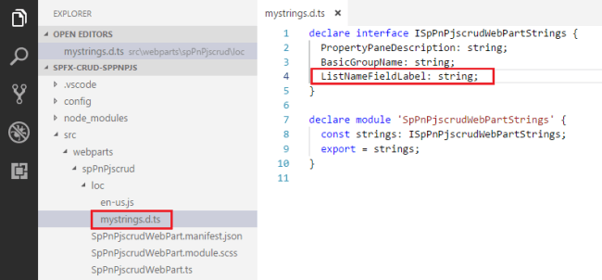

declare **interface** ISpPnPjscrudWebPartStrings {

  PropertyPaneDescription: string;

  BasicGroupName: string;

  DescriptionFieldLabel: string;

}

declare module 'SpPnPjscrudWebPartStrings' {

**const** strings: ISpPnPjscrudWebPartStrings;

**export** = strings;

}

**Step 3**  
In en-us.js file under \src\webparts\spPnPjscrud\loc\ folder set the display name for listName property,

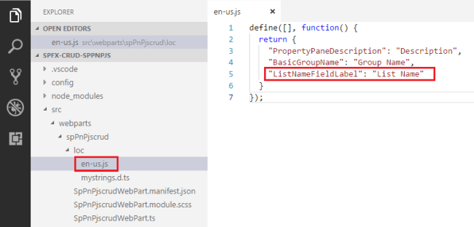

define([], **function**() {

**return** {

    "PropertyPaneDescription": "Description",

    "BasicGroupName": "Group Name",

    "DescriptionFieldLabel": "Description Field"

  }

});

**Step 4**  
Open main webpart file (SpPnPjscrudWebPart.ts) under \src\webparts\spPnPjscrud folder.  
  
**Step 5**  
Rename description property pane field to listName

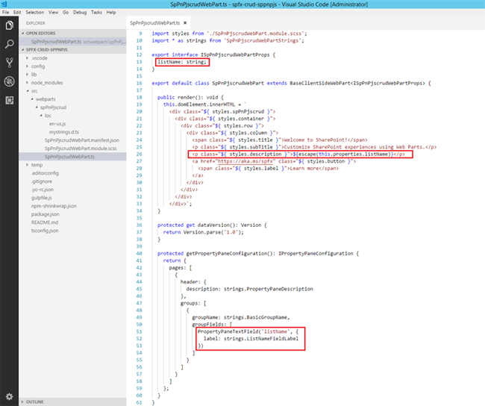

**import** { Version } from '@microsoft/sp-core-library';

**import** {

  BaseClientSideWebPart,

  IPropertyPaneConfiguration,

  PropertyPaneTextField

} from '@microsoft/sp-webpart-base';

**import** { escape } from '@microsoft/sp-lodash-subset';

**import** styles from './SpPnPjscrudWebPart.module.scss';

**import** * as strings from 'SpPnPjscrudWebPartStrings';

**export** **interface** ISpPnPjscrudWebPartProps {

  description: string;

}

**export** **default** **class** SpPnPjscrudWebPart **extends** BaseClientSideWebPart<ISpPnPjscrudWebPartProps> {

**public** render(): **void** {

**this**.domElement.innerHTML = `

      <div **class**="${ styles.spPnPjscrud }">

        <div **class**="${ styles.container }">

          <div **class**="${ styles.row }">

            <div **class**="${ styles.column }">

              <span **class**="${ styles.title }">Welcome to SharePoint!</span>

              <p **class**="${ styles.subTitle }">Customize SharePoint experiences using Web Parts.</p>

              <p **class**="${ styles.description }">${escape(**this**.properties.description)}</p>

              <a href="https://aka.ms/spfx" **class**="${ styles.button }">

                <span **class**="${ styles.label }">Learn more</span>

              </a>

            </div>

          </div>

        </div>

      </div>`;

  }

**protected** get dataVersion(): Version {

**return** Version.parse('1.0');

  }

**protected** getPropertyPaneConfiguration(): IPropertyPaneConfiguration {

**return** {

      pages: [

        {

          header: {

            description: strings.PropertyPaneDescription

          },

          groups: [

            {

              groupName: strings.BasicGroupName,

              groupFields: [

                PropertyPaneTextField('description', {

                  label: strings.DescriptionFieldLabel

                })

              ]

            }

          ]

        }

      ]

    };

  }

}

**Step 6**  
In the command prompt, type “gulp serve”  
  
**Step 7**  
In the SharePoint local workbench page, add the web part.  
  
**Step 8**  
Edit the web part to ensure the listName property pane field is getting reflected.  
  
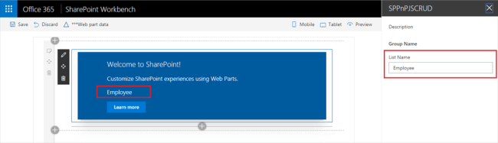

**Model for List Item**Add a class (IListItem.ts) representing the list item.  
  
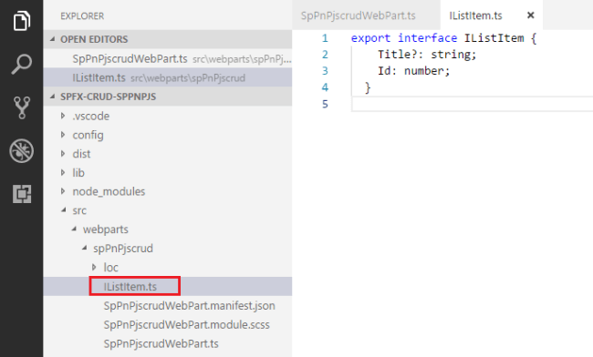

1. **export** **interface** IListItem {
2. Title?: string;
3. Id: number;
4. }

**Add Controls to WebPart**

**Step 1**  
Open main webpart file (SpPnPjscrudWebPart.ts) under \src\webparts\spPnPjscrud folder.  
  
**Step 2**  
Modify Render method to include buttons for CRUD operations and add event handlers to each of the button  
  
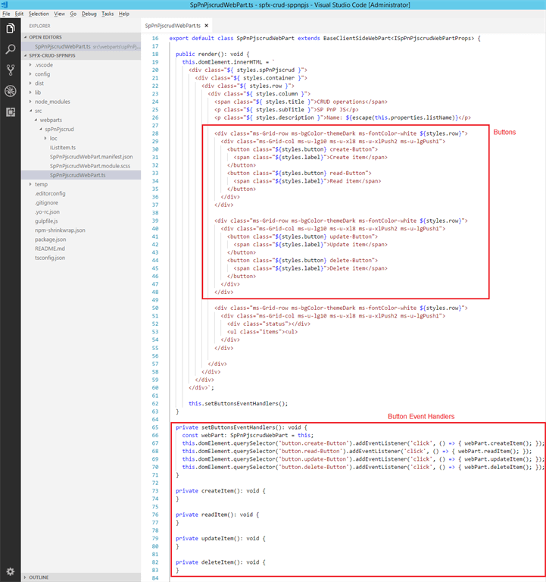

**export** **default** **class** SpPnPjscrudWebPart **extends** BaseClientSideWebPart<ISpPnPjscrudWebPartProps> {

**public** render(): **void** {

**this**.domElement.innerHTML = `

      <div **class**="${ styles.spPnPjscrud }">

        <div **class**="${ styles.container }">

          <div **class**="${ styles.row }">

            <div **class**="${ styles.column }">

              <span **class**="${ styles.title }">CRUD operations</span>

              <p **class**="${ styles.subTitle }">SP PnP JS</p>

              <p **class**="${ styles.description }">Name: ${escape(**this**.properties.listName)}</p>

              <div **class**="ms-Grid-row ms-bgColor-themeDark ms-fontColor-white ${styles.row}">

                <div **class**="ms-Grid-col ms-u-lg10 ms-u-xl8 ms-u-xlPush2 ms-u-lgPush1">

                  <button **class**="${styles.button} create-Button">

                    <span **class**="${styles.label}">Create item</span>

                  </button>

                  <button **class**="${styles.button} read-Button">

                    <span **class**="${styles.label}">Read item</span>

                  </button>

                </div>

              </div>

              <div **class**="ms-Grid-row ms-bgColor-themeDark ms-fontColor-white ${styles.row}">

                <div **class**="ms-Grid-col ms-u-lg10 ms-u-xl8 ms-u-xlPush2 ms-u-lgPush1">

                  <button **class**="${styles.button} update-Button">

                    <span **class**="${styles.label}">Update item</span>

                  </button>

                  <button **class**="${styles.button} delete-Button">

                    <span **class**="${styles.label}">Delete item</span>

                  </button>

                </div>

              </div>

              <div **class**="ms-Grid-row ms-bgColor-themeDark ms-fontColor-white ${styles.row}">

                <div **class**="ms-Grid-col ms-u-lg10 ms-u-xl8 ms-u-xlPush2 ms-u-lgPush1">

                  <div **class**="status"></div>

                  <ul **class**="items"><ul>

                </div>

              </div>

            </div>

          </div>

        </div>

      </div>`;

**this**.setButtonsEventHandlers();

  }

**private** setButtonsEventHandlers(): **void** {

**const** webPart: SpPnPjscrudWebPart = **this**;

**this**.domElement.querySelector('button.create-Button').addEventListener('click', () => { webPart.createItem(); });

**this**.domElement.querySelector('button.read-Button').addEventListener('click', () => { webPart.readItem(); });

**this**.domElement.querySelector('button.update-Button').addEventListener('click', () => { webPart.updateItem(); });

**this**.domElement.querySelector('button.delete-Button').addEventListener('click', () => { webPart.deleteItem(); });

  }

**private** updateItemsHtml(items: IListItem[]): **void** {

  }

**private** readItem(): **void** {

  }

**private** updateItem(): **void** {

  }

**private** deleteItem(): **void** {

  }

**protected** get dataVersion(): Version {

**return** Version.parse('1.0');

  }

**protected** getPropertyPaneConfiguration(): IPropertyPaneConfiguration {

**return** {

      pages: [

        {

          header: {

            description: strings.PropertyPaneDescription

          },

          groups: [

            {

              groupName: strings.BasicGroupName,

              groupFields: [

                PropertyPaneTextField('listName', {

                  label: strings.ListNameFieldLabel

                })

              ]

            }

          ]

        }

      ]

    };

  }

}

**Step 3**  
In the command prompt type “gulp serve” to see the buttons on the webpart.

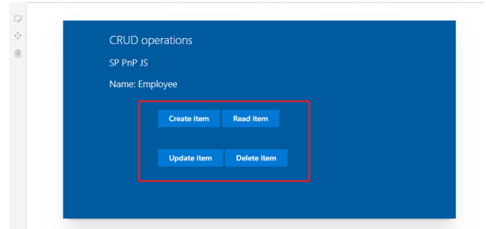

**Step 4**  
We will use the sp-pnp-js APIs to perform CRUD operations. Let us implement generic method which will return the id of latest item from given list using sp-pnp-js APIs.

**private** getLatestItemId(): Promise<number> {

**return** **new** Promise<number>((resolve: (itemId: number) => **void**, reject: (error: any) => **void**): **void** => {

    sp.web.lists.getByTitle(**this**.properties.listName)

      .items.orderBy('Id', **false**).top(1).select('Id').get()

      .then((items: { Id: number }[]): **void** => {

**if** (items.length === 0) {

          resolve(-1);

        }

**else** {

          resolve(items[0].Id);

        }

      }, (error: any): **void** => {

        reject(error);

      });

  });

}

**Import sp-pnp-js**Add below import statements to main web part (SpPnPcrudWebPart.ts).

1. **import** { IListItem } from './IListItem';
2. **import** pnp, { sp, Item, ItemAddResult, ItemUpdateResult } from "sp-pnp-js";

**Implement Create Operation**

We will use the sp-pnp-js API of items.add to add the item to list

**private** createItem(): **void** {

**this**.updateStatus('Creating item...');

    sp.web.lists.getByTitle(**this**.properties.listName).items.add({

      'Title': `Item ${**new** Date()}`

    }).then((result: ItemAddResult): **void** => {

**const** item: IListItem = result.data as IListItem;

**this**.updateStatus(`Item '${item.Title}' (ID: ${item.Id}) successfully created`);

    }, (error: any): **void** => {

**this**.updateStatus('Error while creating the item: ' + error);

    });

**Implement Read Operation**

We will use sp-pnp-js API - getById to read the item.

**private** readItem(): **void** {

**this**.updateStatus('Reading latest items...');

**this**.getLatestItemId()

      .then((itemId: number): Promise<IListItem> => {

**if** (itemId === -1) {

**throw** **new** Error('No items found in the list');

        }

**this**.updateStatus(`Loading information about item ID: ${itemId}...`);

**return** sp.web.lists.getByTitle(**this**.properties.listName)

          .items.getById(itemId).select('Title', 'Id').get();

      })

      .then((item: IListItem): **void** => {

**this**.updateStatus(`Item ID: ${item.Id}, Title: ${item.Title}`);

      }, (error: any): **void** => {

**this**.updateStatus('Loading latest item failed with error: ' + error);

      });

  }

**Implement Update Operation**

We will use sp-pnp-js API - update

**private** updateItem(): **void** {

**this**.updateStatus('Loading latest items...');

    let latestItemId: number = undefined;

    let etag: string = undefined;

**this**.getLatestItemId()

      .then((itemId: number): Promise<Item> => {

**if** (itemId === -1) {

**throw** **new** Error('No items found in the list');

        }

        latestItemId = itemId;

**this**.updateStatus(`Loading information about item ID: ${itemId}...`);

**return** sp.web.lists.getByTitle(**this**.properties.listName)

          .items.getById(itemId).get(undefined, {

            headers: {

              'Accept': 'application/json;odata=minimalmetadata'

            }

          });

      })

      .then((item: Item): Promise<IListItem> => {

        etag = item["odata.etag"];

**return** Promise.resolve((item as any) as IListItem);

      })

      .then((item: IListItem): Promise<ItemUpdateResult> => {

**return** sp.web.lists.getByTitle(**this**.properties.listName)

          .items.getById(item.Id).update({

            'Title': `Updated Item ${**new** Date()}`

          }, etag);

      })

      .then((result: ItemUpdateResult): **void** => {

**this**.updateStatus(`Item **with** ID: ${latestItemId} successfully updated`);

      }, (error: any): **void** => {

**this**.updateStatus('Loading latest item failed with error: ' + error);

      });

  }

**Implement Delete Operation**

We will use sp-pnp-js API - delete

**private** deleteItem(): **void** {

**if** (!window.confirm('Are you sure you want to delete the latest item?')) {

**return**;

  }

**this**.updateStatus('Loading latest items...');

  let latestItemId: number = undefined;

  let etag: string = undefined;

**this**.getLatestItemId()

    .then((itemId: number): Promise<Item> => {

**if** (itemId === -1) {

**throw** **new** Error('No items found in the list');

      }

      latestItemId = itemId;

**this**.updateStatus(`Loading information about item ID: ${latestItemId}...`);

**return** sp.web.lists.getByTitle(**this**.properties.listName)

        .items.getById(latestItemId).select('Id').get(undefined, {

          headers: {

            'Accept': 'application/json;odata=minimalmetadata'

          }

        });

    })

    .then((item: Item): Promise<IListItem> => {

      etag = item["odata.etag"];

**return** Promise.resolve((item as any) as IListItem);

    })

    .then((item: IListItem): Promise<**void**> => {

**this**.updateStatus(`Deleting item **with** ID: ${latestItemId}...`);

**return** sp.web.lists.getByTitle(**this**.properties.listName)

        .items.getById(item.Id).**delete**(etag);

    })

    .then((): **void** => {

**this**.updateStatus(`Item **with** ID: ${latestItemId} successfully deleted`);

    }, (error: any): **void** => {

**this**.updateStatus(`Error deleting item: ${error}`);

    });

}

**Test the WebPart**

1. On the command prompt, type “gulp serve”
2. Open SharePoint site
3. Navigate to /_layouts/15/workbench.aspx
4. Add the webpart to page.
5. Edit webpart, in the properties pane type the list name
6. Click the buttons (Create Item, Read Item, Update Item, and Delete Item) one by one to test the webpart
7. Verify the operations are taking place in SharePoint list.

**Create Operation**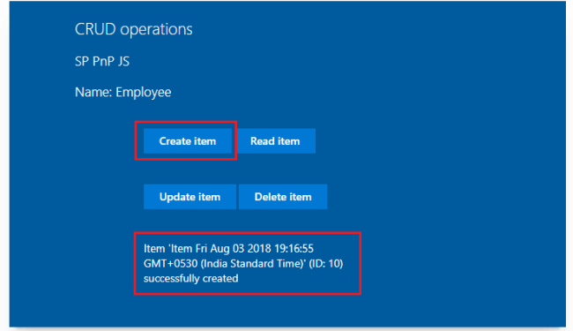  
  
**Read Operation**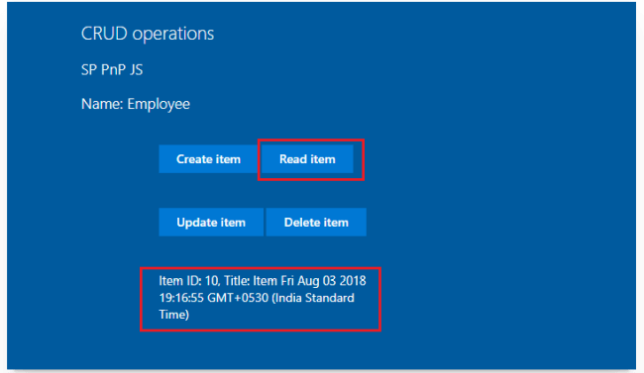

**Update Operation**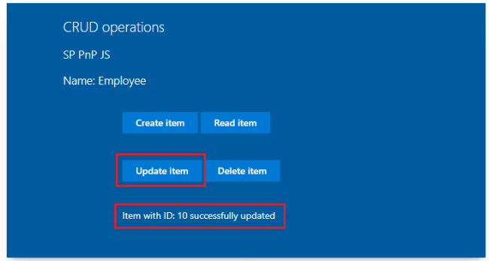

**Delete Operation**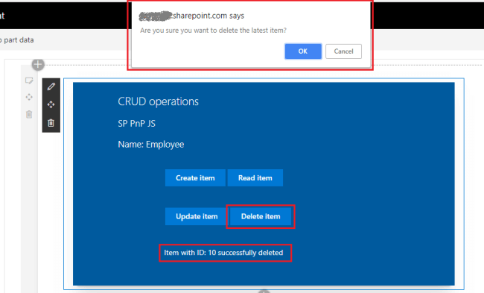  
  
**Troubleshooting**In some cases SharePoint workbench (https://[tenant].sharepoint.com/_layouts/15/workbench.aspx) shows the below error although “gulp serve” is running.

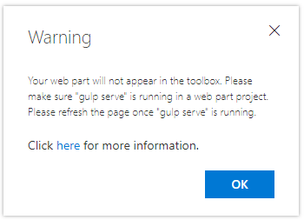

Open below url in the next tab of browser. Accept the warning message.  
  
*https://localhost:4321/temp/manifests.js***Summary**sp-pnp-js APIs helps to perform common operations (like CRUD) with SharePoint easily. It makes the code easier to maintain. Developers can concentrate on business logic rather than worrying about the identifying and using various REST APIs to use in the code.